Your logo etc

Hi,

Here is the information I need from you to launch your first Viral Prize Draw.

Please email the information to me at emailadress@you.com as soon as possible so I can get everything set up for you.

Don't worry if you can't get the wording or all of the details exactly as you want them at the moment. Just send what you can to me now and we can tweak it to get it just right when we see how it looks on the website.

Also, please feel free to call me on xxxx xxxxxxxx to discuss any of the information below, or the prize you are thinking of giving. In general, the better the prize, the more people will enter and the quicker you will build your email list, which in turn means the sooner you will be able to send them offers and information about you to tempt them to keep coming back to you time after time.

Firstly, here's the information I need about you and your business...

Your Information

- Your Business Name

- Your Website URL (ie www.MyBusiness.com)

- Your Name

- Telephone Number

- Email Address

- Business Facebook Page URL (if any)
( ie https://www.facebook.com/businessname/261772773476 )

- Business Twitter Name (if any) (ie @businessname )

and on the next page is the information I need from you to set up the Prize Draw...

Prize Draw Information

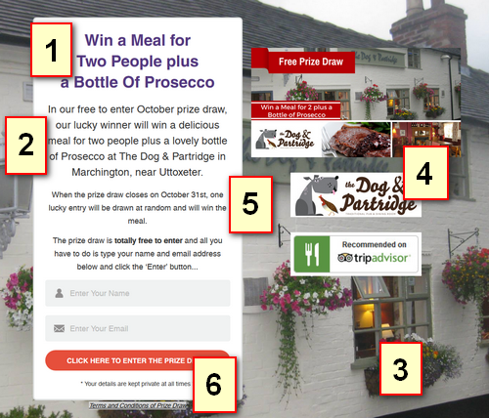

- Prize Draw Title
This would usually start with the word 'Win', give brief details of the prize, and could include your town or city name. As well as being the title on the Prize Draw page itself, it is also the title of the Facebook and Twitter post when people share the prize draw so it should also be less than 100 characters in length. Example: Win a Meal for Two at The XYZ Restaurant in Bournemouth.

- Prize Draw Details
This is whatever information you want to give about your prize. The better it sounds, the more people will want to enter the prize draw and the more you will grow your email list. Here are some ideas of wording for you. You are welcome to use one of these exactly, or amend the wording as you see fit...
In this free to enter prize draw from XYZ restaurant, one lucky winner will receive a superb meal for two plus a bottle of wine worth up to £x.
Your evening will begin with a glass of bubbly on arrival and you'll then both be able to select three courses from our full menu.
Or
This is your chance to win a very special meal for two at XYZ Restaurant in ABC Town.
After enjoying a glass of bubbly on arrival, our winners will choose their three-course dinner from our main menu, to be accompanied by a glass of wine specially chosen to complement each course.
- Main Background Image
This could be a photo of your business or some other relevant image. Ideally, please email this to me in jpg, png or bmp format but if the image you want to use is already on your website, please let me know which image it is and I can take it from there. It will need to be quite a large image because it fills the whole of the prize draw background.
- Prize Draw Photos or Images
These should ideally be a photo or two that are relevant to the prize that is being offered. Photos of the prize itself or other relevant images.
- Start and End Date
I'd recommend that prize draws last for a calendar month but what dates would you like your prize draw to start and finish?
- Prize Draw Restrictions
Would you like to add any restrictions as to when the prize can or can't be taken? The fewer restrictions the better as we don't want to put anyone off entering, but restrictions you may want to consider are: Can't be used in conjunction with any other offer, can not be taken on Valentine's day, Mothers Day etc.

As I mentioned above, if you have any questions about the prize draw or your prize, just give me a call on xxxx xxxxxxxxxx – I'm here to help you!

As soon as you email all the information to me I can start getting your Viral Prize Draw to work for you.

I look forward to working with you to build your email list.

Best regards,

Your Name

