Hi [NAME],

Thank you for your email. As requested, here are some details of the system I have developed...

It’s a system that will create a real asset for your business that will help you to attract new customers as well as tempt your existing customers to spend money with you more frequently.

With my system, I will quickly build you a large email list of your customers and potential customers and then turn that list into extra sales for you.

So now you can see how profitable an email list can be for your business. But an email list can only get you sales if there are lots of people on it... people who are highly targeted prospects for you. And that is where my Viral Prize Draw Software comes in!

With my Viral Contest Software we'll offer a prize of your choosing (something such as a XXXXXXXX would work great) and I'll then create an attractive looking entry page for the draw.

Here's an example contest...

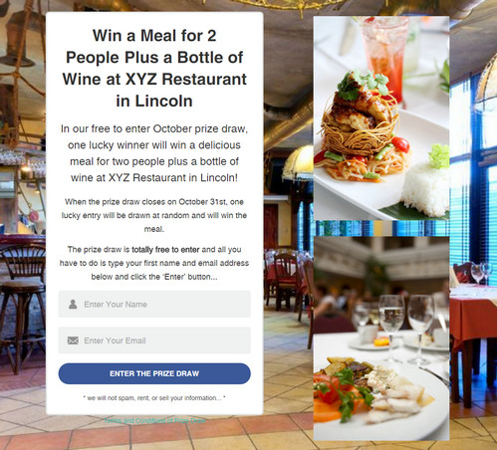

So people in your area see the draw online and give you their name and email address to enter the draw. That adds them to your email list. But that's not all... then the magic of the system happens...

Once they've entered, they then see a page like this...

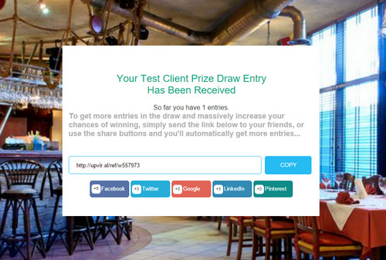

This gives them the chance to get more entries in the draw (and increase their own chances of winning the prize) by sharing the draw online on Facebook, Twitter etc.

Most people want to increase their chances of winning and so use the button to share the draw. This causes the viral effect because people share the draw which means more people enter the draw which means more share it... and so on. And each person who enters is another person on your email list that you can promote your [xxxproducts and servicesxxx] month after month.

It is not unusual for one Viral Prize Draw to build a list of 300, 500 or even 1000+ people. All people who are in your area that want to hear about you.

And this will just be the beginning…
Over time, your database will continue to grow, becoming an even more powerful asset, tempting even more local people to your business.

How much does it cost?

With my full done-for-you system, I not only set up your viral prize draws but also look after the monthly management of your email list and the sending out of your newsletters. This includes all of the following…
Initial Setup
- Set up of your first prize draw with my Viral Prize Draw Software
- Set up of the standalone website which hosts your prize draws. This will have its own domain name relevant to your business.
- Set up of your email list system with GetRepsonse. This is a paid for service, but with my Done-For-You system, all costs are included.
With my Done-For-You system, your initial setup is included at no extra charge.
Fully Managed Monthly Newsletters
There is no point building a large email list of your customers and potential customers and then not sending them anything and so the Done-For-You system also includes the creating and sending of a newsletter each month. You will need to tell me what you want to include in the newsletter of course as you know your business far better than me, but the design of an attractive looking newsletter and the sending it to your growing list, is taken care of for you each month.
As an example, your newsletter could include offers to attract customers at times when you’re normally quietest, details of special events, new products or other news from your business. Anything that will keep your business in your customer’s mind and tempt them to buy from you rather than one of your competitors.
So every month your Done-For-You system includes…
- Fully managed solution so whenever you want a newsletter sending to your list (up to once per month), you simply send the wording and any images to me and I will format the newsletter and send it to your ever growing list (after you have seen and agreed a proof copy of course)
- All GetResponse email list software costs
- Ongoing management of your email list
- The email list we build is yours and yours alone. You are welcome to have a copy of the list at any time and if you ever decide to leave the system, your entire list will be sent to you so you can still use it.
- Telephone support and help from me when needed
- Web hosting costs for your Viral Prize Draw Software
- Set up of further Viral Prize Draws as and when required. Many businesses run a different prize draw every month to ensure the email list continues to grow. All of this is included for you.

Your total investment per month is just $60
This low monthly cost is paid by direct debit and covers a list of up to 500 people. When your list grows above that figure and so is even more profitable for you, your monthly cost will increase by $30 for every 500 people on your list. So, ongoing costs for a list of 501 to 1000 people will be $90, 1001 to 1500 will be $120 etc. This is because of the incremental increase in email list software costs but it means that your costs only rise when you already have the list and the increase in profits to make it more than worthwhile.
No long term contract. I’ll be working hard to ensure that your email list is constantly profitable for you, but if you ever decide to cancel, then you can do so at any time and the email list you have built will be yours to keep and use as you wish.
Just a tiny 2% response from a list of 1000 can increase your weekly revenue by over $900 and so I know that the small monthly cost will be the best marketing investment you’ll make.
To order the Viral Prize Draw Software with my Done-For-You system, please send payment to [PAYPAL EMAIL ADDRESS]
Please contact me if you have any questions or would like to discuss the possibility further. Other payment methods are also available.

I look forward to working with you.

Best regards,

